**PLANT DISEASE CLASSIFICATION USING CNN**

## A PROJECT REPORT

***Submitted by***

## NIVETHITHA CHOWTHRI (210701185)

***in partial fulfillment for the award of the degree of***

# BACHELOR OF ENGINEERING

***in***

**COMPUTER SCIENCE AND ENGINEERING**



# RAJALAKSHMI ENGINEERING COLLEGE

# ANNA UNIVERSITY, CHENNAI

## MAY 2024

**RAJALAKSHMI ENGINEERING COLLEGE, CHENNAI**

# BONAFIDE CERTIFICATE

Certified that this Thesis titled **“DEMAND FORECAST IN SUPPLY CHAIN MANAGEMENT**” is the bonafide work of “**NIVETHITHA CHOWTHRI (2116210701185)”**who carried out the work under my supervision. Certified further that to the best of my knowledge the work reported herein does not form part of any other thesis or dissertation on the basis of which a degree or award was conferred on an earlier occasion on this or any other candidate.

## SIGNATURE

Dr . S Senthil Pandi M.E.,Ph.D.,

## PROJECT COORDINATOR

Professor

Department of Computer Science and Engineering Rajalakshmi Engineering College

Chennai - 602 105

Submitted to Project Viva-Voce Examination held on **_**

**Internal Examiner External Examiner**

**LEVERAGING MACHINE LEARNING FOR ACCURATE DEMAND FORECAST IN SUPPLY CHAIN**

**MANAGEMENT**

**Abstract**:

Any business that operates inside a network of supply chains needs an effective supply chain management system. Retaining the enterprise's competitiveness and reputation requires the capacity to manage production and product transportation efficiently. This is especially true for sectors like the apparel industry. This study proposes and conducts a thorough investigation of Deep Reinforcement Learning approaches for apparel supply chain optimisation, with an emphasis on Soft Actor-Critic. Metrics including the inventory-to-sales ratio, service level, and sell-through rate are used to test and compare six distinct models. The Soft Actor-Critic model outperforms various other Actor Critic models in terms of inventory control and demand fulfilment.Furthermore, particular metrics are computed to assess the models' performance during the experiment. Soft Actor-Critic makes sure there is enough merchandise available for sale without accumulating too much inventory, which results in a better balance between sell-through rate and service level. S-policy, Trust Region Policy Optimisation, and Twin Delayed Deep Deterministic Policy Gradient models all demonstrate a strong balance between sell-through rate and service level, according to numerical testing. Additionally, SoftActor-Critic exhibits notable gains over S-policy, Twin Delayed Deep Deterministic Policy Gradient, and Trust Region Policy Optimisation models, with inventory sales ratios that are, respectively, 7%, 41.6%, and 42.8% lower. This suggests that it has a better capacity to keep inventory levels that support sales and profitability.

**Keywords**: Supply chain management, Deep Reinforcement Learning, Trust Region Policy Optimization

**1.Introduction:**

This document's introduction is divided into two main subsections: the study's motivation and its contribution. Each of these subsections is essential to understanding the background and importance of the research being done.

A. MOTIVATION:

Supply Chain Management (SCM) serves as a cornerstone for the prosperity of enterprises, particularly amidst the backdrop of intensifying global trade competition. It is imperative for enterprises to continuously refine their SCM operations to maintain a competitive edge in the marketplace. Central to the success of SCM is effective inventory management (IM), which involves making timely ordering decisions to meet product demand. This aspect is equally vital in the apparel industry. Traditionally, various mathematical approaches such as linear programming, dynamic programming, and heuristic models have been employed in inventory management. However, these methods often encounter limitations, especially in scalability and reliance on domain-specific knowledge. With the emergence of deep neural networks (DNN), particularly Deep Reinforcement Learning (DRL), there is a growing recognition of its potential in addressing SCM challenges, especially in scenarios where specific data distributions or assumptions are not readily available. Demand variability further complicates inventory management, necessitating innovative solutions. While recent research has explored DRL for inventory optimization, there remains a significant gap in data-driven inventory control using DRL. Existing approaches predominantly rely on discrete-based DRL methods, limiting their applicability to problems with large action spaces. Furthermore, these approaches are frequently evaluated only on the basis of reward values, ignoring important key performance indicators (KPIs) that indicate how well inventory

management systems are working.

B. CONTRIBUTION:

This study uses the sophisticated DRL model Soft Actor Critic (SAC) to close current gaps in inventory management. SAC provides a data-driven method for managing stock levels, enabling well-informed choices for the best possible inventory control. The study addresses the need for a realistic depiction of Supply Chain Inventory Management (SCIM) entities by considering into account numerous retailers in accordance with the regional distribution of the dataset. SAC has exceptional proficiency in managing implicit patterns and distributions in demands, providing a workable approach to attaining profitable inventory management.

The design of a make-to-stock (MTS) inventory management system specifically for clothing products, a thorough investigation of the various DRL models with explicit inventory management performance analysis, and a data-driven analysis using SAC for optimal inventory management are among the contributions of this research. This work is noteworthy since it is the first documented attempt to look into inventory management with SAC.

C. ORGANIZATION OF STUDY:

This paper's following sections are arranged as follows: The related literature on multi-echelon-based inventory management and the use of DRL in inventory control systems is examined in Section II. The problem statement and the underlying supply chain model are explained in Section III. An extensive discussion of the SAC method used to approach the problem is given in Section IV. A well-balanced inventory management system may be established by utilising SAC, as evidenced by the comparative performance of the system and the experimental findings and numerical data presented in Section V. Experiment data and related graphics are included in Section VI, and the study's conclusion and future research directions are outlined in Section VII.

**2. Proposed Methodology:**

2.1)Data collection:

Data for analysis is sourced from Kaggle, a popular platform for

datasets. The dataset selected for examination includes the following

attributes: ● - Store: Identifies the store number.

● - Date: Indicates the week of sales.

● - Weekly_sales: Represents the sales figure for a particular store in that week. ● - Holiday_flag: Indicates whether it is a holiday week.

● - Temperature: Reflects the local temperature during that week. ●

- Fuel_Price: Represents the cost of fuel during the specified period.

● - The Consumer Price Index, or CPI, monitors changes in the costs of a typical basket of items and services over time.

● - Unemployment: Indicates the unemployment rate during the week.

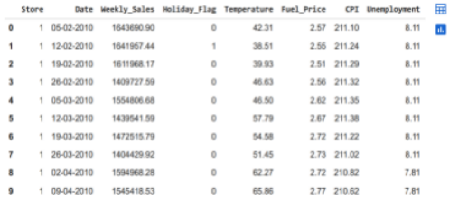

above Fig. is the output generated for df.head(10), it displays the first ten entries of the dataset.

2.2. ) **Basic Analysis of data**

We begin by conducting a basic analysis of the data, focusing on its description and checking for duplicate values. It's essential to perform an initial integrity check to identify any inconsistencies or anomalies within the dataset. This entails searching for potential issues such as missing values, duplicates, or inaccuracies in data entries before proceeding further.

2.3. ) **Preprocessing of data**

Data preprocessing involves addressing issues such as missing values, duplicates, and inconsistent entries to maintain data integrity. Utilizing tools like Pandas and NumPy, techniques including imputation, duplicate removal, and data type conversions are implemented to clean the data effectively. Summary of the DataFrame is obtained. This dataframe can be used to get information about the central tendency, dispersion, and shape of the data.

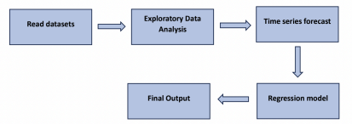

2.4. ) **Feature engineering**

Feature engineering involves shaping the input dataset to meet the specific requirements of a particular model or machine learning algorithm. This process enhances the performance of machine learning models significantly.

2.5. ) **Exploratory data analysis**

Perform Exploratory Data Analysis (EDA) to uncover insights within the dataset, such as detecting trends, correlations, and seasonal patterns. Utilize various visualization methods like time series plots, histograms, boxplots, scatterplots, and heatmaps, along with summary statistics. EDA aids in evaluating the relationship between sales and potential predictors or influencing factors.

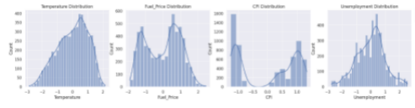2.6. ) **Splitting of dataset**

A model validation process called "train test split" lets you simulate how a model might function with fresh, untested data. Ensure that the format in which your data is organised is suitable for the train test split. This involves splitting the entire data set into "Features" and "Target" in scikit-learn. Divide the data set into a testing set and a

training set. To do this, take a random sample of approximately 75% of the rows (you can change this number) and add them to your training set without replacing them. You add the remaining twenty-five percent to your test set. It should be noted that for a given train test split, the colours in "Features" and "Target" indicate where their data will go ("X_train," "X_test," "y_train," and "y_test"). The model is trained and constructed using the training dataset. The system needs to be able to recognise trends in order to produce precise forecasts. The testing dataset will only be used to assess performance following forecast. To avoid bias in the training or testing sets, make sure the data points are randomised when separating the data. The datasets' ability to accurately reflect the data's broad distribution is aided by randomization. Neglecting to divide the data into training and testing sets results in skewed outcomes and a misleading sense of increased model accuracy.

2.6. ) **Train the model**

Model training initiates the machine learning process by developing a functional model for subsequent validation, testing, and deployment.

It involves feeding training data to an ML algorithm, composed of features and targets, to learn from. The model processes input data through the algorithm, comparing the output to the expected results, and adjusts accordingly. The accuracy of the training and validation datasets influences the precision of the model, determining its efficacy

in real-world applications. This iterative process is known as model fitting.

2.7. ) **Test the model**

Model testing involves evaluating whether an ML model achieves the desired outcome. Passing tests indicate readiness for deployment, while failures necessitate further development and testing. This process evaluates a fully trained model's performance on a separate testing set, ensuring it follows the same probability distribution as the training set. Each sample in the testing set has a known target value, allowing comparison between the model's predictions and the actual targets to measure performance.

2.7. ) **Implement the model**

Incorporate the machine learning algorithms into your model and execute the program. If your project necessitates it, create a user interface where users can input their preferences, which are then transmitted to the model. Deployment involves transferring an ML model from an offline setting and merging it into an operational production environment. Lastly, comprehensive testing and validation are essential.

**3. Result Discussion:**

The dataset is divided into training and test datasets after

exploratory data analysis (EDA). In this case, the classes that are accessible are used to classify the datsets, and their probabilities are calculated.

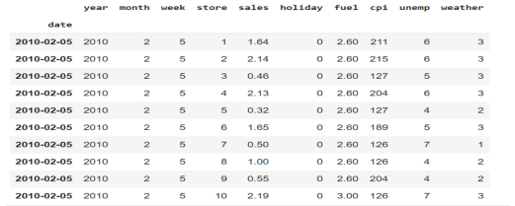

The following machine learning models were worked on the datasets:

i. Linear Regression

ii. Ridge

iii. KNN Regressor

iv. Decision Tree

v. Random Forest

vi. XGBoost

On working with the above models, the output generated is as follows.

|  |  |  |
| --- | --- | --- |
| **Models** | **Training**  **Accuracy** | **Test accuracy** |
| Linear  Regression | 97.7 | 95.899999 |
| Ridge | 97.7 | 95.89999 |
| KNN  Regressor  Decision  Tree | 100.0  97.3 | 91.9  93.5 |
| Random  forest  XGBoost | 98.6  99.8 | 95.3999  96.8 |

Despite its flaws, SAC performed well better than other models in a number of areas, proving its applicability and reliability in obligations associated with inventory management. First off, despite having a lower sell-through rate than A 2 C, it made sure that more customer requests were met by surpassing A2C's service quality by a significant margin of 971.7%. In comparison with SAC, random policy produced a superior service level. However, SAC refrained from overstocking, which may have required unsettling control of stocks efforts. It managed this by increasing the

sell-through rate by 272.7%. Furthermore, SAC outperformed S-policy in ensuring that every unit of sales is equal to the inventory levels held by the shops, achieving a 7% lower inventory-to-sales ratio.

Accuracy of predictions from predicted test input features should be greater than or at least equal to accuracy of predictions from time series forecast algorithms.



The range of accuracy of predictions made from predicted test input features should match the accuracy of predictions made from real test input features, as indicated by the term "accuracy_threshold".

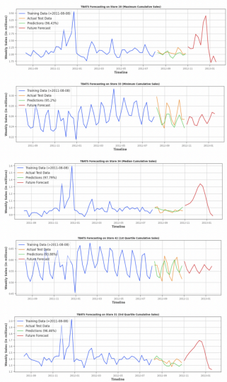

The graph between various timelines and weekly sales (in millions).It talks about the training data, actual test data, predictions, and future forecast.

**4.Literature Survey**:

1. T. Vignesh, S. Yogeendran, P. Sabarish, Dr. C. Shyamala, "Walmart Sales Prediction Using Machine Learning Algorithms": The use of machine learning algorithms to forecast sales at Walmart is investigated in this study. It probably looks into different methods and models to maximize the accuracy of sales forecasting while utilizing Walmart's enormous data set.

2.A Comparative Analysis of Demand Forecasting Models for a Multi-Channel Retail Company: Arnab Mitra, Arnav Jain, Avinash Kishore, and Pravin Kumar: A Novel Hybrid Machine Learning Approach" This study compares many demand forecasting models, paying special attention to a hybrid machine learning strategy designed for multi-channel retailers. Most likely, the study assesses how well different algorithms perform.

3. Shyam Kumar Barode and Veer Singh Chandraul's "A Review on Demand and Forecasting in Supply Chain Management": An overview of demand forecasting in supply chain management is given in this review paper. It probably goes over how crucial precise demand forecasting is to efficient supply chain optimization, logistics, and inventory management. The review could go over various methods, difficulties, and new developments in demand forecasting.

4. "Walmart’s Sales Data Analysis – A Big Data Analytics Perspective" : This viewpoint probably explores the use of big data analytics to analyze Walmart

sales data.

5. "Walmart Sales Forecast using Machine Learning (IJCRT)": This article most likely offers a particular machine learning-based sales forecasting model for Walmart. In an effort to increase Walmart's operational effectiveness and profitability, it might go into depth about the model architecture, development process, and assessment metrics used to anticipate sales with accuracy.

6. Demand forecasting is probably covered in the Taulia.com site as a crucial component of improved supply chain management. It might draw attention to how important demand forecasting is to the supply chain ecosystem's ability to manage inventories efficiently, cut expenses, and boost customer happiness.

**5.) References:**

I. Walmart Sales Prediction by Dr. C. Shyamala, P. Sabarish, T. Vignesh, and S. Yogeendran Through Machine Learning Algorithms

ii. Arnab Mitra, Arnav Jain, Avinash Kishore, and Pravin Kumar. A Comparative Analysis of Demand Forecasting Models for a Multi-Channel Retail Company: A Novel Hybrid Machine Learning Approach. iii. Veer Singh Chandraul and Shyam Kumar Barode's Review of Demand and Forecasting in Supply Chain Management.

iv. A Big Data Analytics Viewpoint of Walmart's Sales Data Analysis v. Walmart Sales Forecasting using Machine Learning (IJCRT)